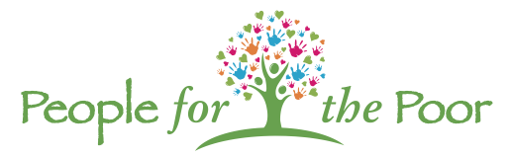

SPONSORSHIP & GOLFER REGISTRATION
White Oaks Country Club – Monday, September 18, 2023

SPONSORSHIP CONTACT INFORMATION

Sponsoring Organization or Individual: (The sponsorship will be recognized using this name) _______________________________________

Contact Person: __________________________________________________________________________________________

Address: _______________________________________________________ Phone: _________________________________

City: ___________________________________________________________ Email: _________________________________

MAJOR SPONSORS EXCLUSIVE SPONSORS SPONSORS
☐ Diamond Sponsor $5,000 ☐ Open Bar Sponsor $1,500 ☐ Beverage Cart Sponsor $ 500
☐ Gold Sponsor $3,000 ☐ Golf Cart Sponsor $ 750 ☐ Pin Flag Sponsor $ 200
☐ Silver Sponsor $2,000 ☐ Hole Sponsor $ 100
☐ Bronze Sponsor $1,000

Sponsorship Total $ ________

GOLFER REGISTRATION Golfer Name Address Phone #
☐ Individual $125 #1 ________________________________________________________________
☐ Foursome $500 #2 ________________________________________________________________

Golfer Total $ _______________ #3 ________________________________________________________________
(@ $125 ea)
#4______________________________________________________________________________

Contribution  Sponsorship Total _____________  Golfer Total __________________  (@$125 each)  GRAND TOTAL _____________ | Payment Method  ☐ Check Enclosed ☐ Credit Card ☐ Please bill us  Please circle Credit Card: VISA MasterCard AMEX  CREDIT CARD # _______________________________________________________  CREDIT CARD EXP. DATE ______________ SECURITY CODE _____________  NAME ON CARD _______________________________________________________  SIGNATURE ___________________________________________________________  Pay online @peopleforthepoor.org or mail check to:  People for the Poor | PO Box 821 | Bellmawr, NJ 08099

For information contact: Mike Scott 267-567-8822 or John Ross 609-685-1784

