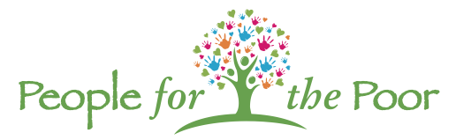
ANNUAL GOLF OUTNG
Helping the Homeless and the Hungry
Monday, September 18, 2023

White Oaks Country Club
Newfield, NJ
SPONSORSHIP OPPORTUNITES
DIAMOND SPONSOR ($5,000)  - Eight golfers  - Dinner for eight registered golfers  - Company Logo on main event banner  - Company sign with logo at Registration/reception/dinner  - Company sign with logo at a Prize Hole  - Company link on People for the Poor website  - Raffle tickets for 8 golfers for events throughout the day | GOLD SPONSOR ($3,000)  - Four golfers  - Dinner for four registered golfers  - Company Logo on main event banner  - Company sign with logo at Registration/reception/dinner  - Company sign with logo at a Prize Hole  - Company link on People for the Poor website
SILVER SPONSOR ($2,000)  - Two golfers  - Dinner for two registered golfers  - Company Logo on main event banner  - Company Logo sign at a Prize Hole | BRONZE SPONSOR ($1,000)  - One golfer  - Dinner for registered golfer  - Company logo on main event banner  - Company logo sign at a Prize Hole

Exclusive Sponsor  - $1,500 Open Bar Sponsor  - $ 750 Golf Cart Sponsor | Sponsor  - $500 Beverage Cart Sponsor (on course)  - $225 Pin Flag Sponsors (suitable for framing)  - $125 Hole Sponsors

NOTE: Sponsor commitment must be made before September 1 to be included in promotional signage.

“No one is more cherished in this world than someone who lightens the burden of another.”
- Mother Teresa

White Oaks Country Club | 2951 Dutch Mill Road | Newfield, NJ
$150 per golfer | Registration 10:00 am | Shotgun Start 12 noon

www.peopleforthepoor.org
People for the Poor | PO Box 821 | Bellmawr, NJ 08099

